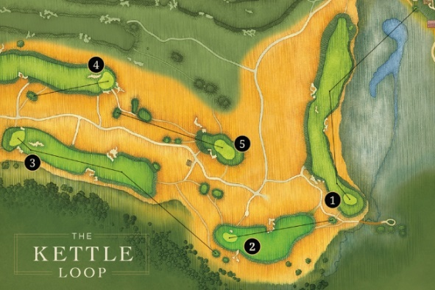
Kettle Loop - Basic Info
Available for overnight guests only.

Five holes: Starts on #1 Tee near fire pits by the Lodge. Ends on the 6th green where a staff member will be there to pick up guests.

Each hole is set up to provide a different perspective of that hole than during the regular round.

Takes about 1 hour to an 1 ½ hour’s to complete.

Green fee: is complimentary. If a guest would like to use a caddie there is no caddie fee but there is a recommended $40 gratuity paid directly to the caddie.

Intended to let overnight guests who are arriving mid-late afternoon get a feel for the course before their round the next day and for guests who are spending two nights and want more than 18 holes between the two nights.

Not available on Mondays because of course maintenance.

The Drumlin - Basic Info
The Drumlin is designed to provide Erin Hills Guests an after-golf activity to complete the Erin Hills experience.

COST - Complimentary for Erin Hills golf and lodging guests.

HOURS 11:00 am – 11:30 pm Complete – 45 to 60 minutes

TIME to Complete – 45 to 60 minutes.

FACTS
Not the same putting surface or conditions as the golf course.
Daily set-up will feature a 12-hole course.

MAINTENANCE
Tee locations will be moved daily and holes will be changed twice a week.

Top Tracer- Basic Info
Erin Hills practice facility is equipped with Toptracer Range technology and offers a fun, engaging, tech-driven experience that appeals to seasoned players, range rivals, friends, family members, and even first-time golfers.

COST- Complimentary to all Erin Hills golf and lodging guests.
HOURS: Open for use during normal practice facility hours.
Not available Mondays from 2 p.m. to 6 p.m.

FACTS: Guests can download the Top Tracer Mobile app and
begin hitting in the Top Tracer area at the Practice facility. Four stations will be set up with tablets after the last tee time goes out for the day for guests to utilize.

